**Project Title:-**  **EduConsultPro CRM Implementation: Streamlining Admission and Enquiry Management**

**1. Project Overview**

This project focuses on the development of a CRM application to streamline the services offered by EduConsultPro Institute. As a leading educational institution, EduConsultPro offers diverse courses and programs and faces challenges in managing the growing number of student enquiries, admission processes, and consulting services. The goal of this project is to provide a comprehensive solution leveraging Salesforce CRM to enhance operational efficiency, improve user experience, and support EduConsultPro's long-term vision.

**2. Objectives**

**Business Goals:**

- Streamline the admission process for prospective students.

- Improve the transparency and efficiency of the enquiry management system.

- Enable effective case management for expert consulting services.

**Specific Outcomes:**

- A centralized system for managing student enquiries and applications.

- Automation of admission reviews and processes.

- Enhanced transparency in student interactions.

**3. Salesforce Key Features and Concepts Utilized**

The project leverages Salesforce CRM's key features, including:

- Customizable dashboards and reports for admission tracking.

- Workflow automation for enquiry and application processing.

- Case management for expert consulting services.

- Integration with other systems for seamless data exchange.

**4. Detailed Steps to Solution Design**

The solution design involves the following key steps:

1. Creating data models to represent courses, students, enquiries, and cases.

2. Designing user-friendly interfaces for admissions staff and prospective students.

3. Implementing business logic and workflows to automate processes.

4. Ensuring proper documentation with screenshots and diagrams for each module.

**Custom Objects:**

1. Course 2. Consultant 3. Student 4. Appointment

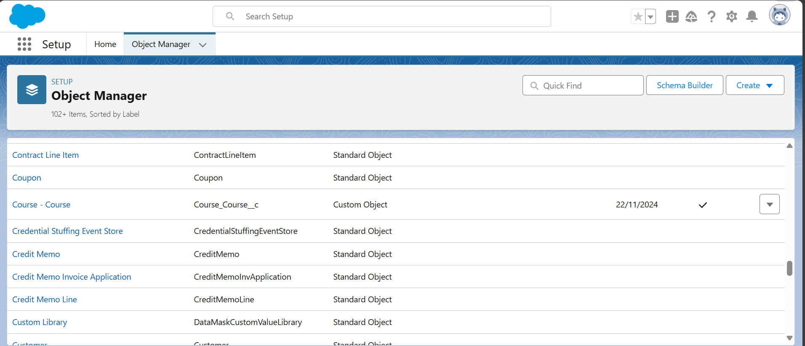

**Relationship Among the Objects:**

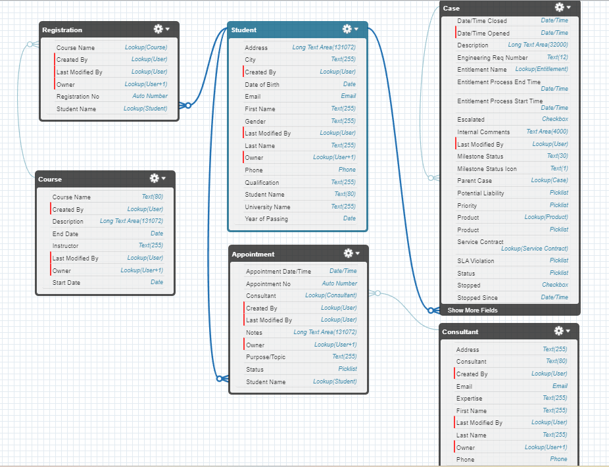

**Custom Tabs:**

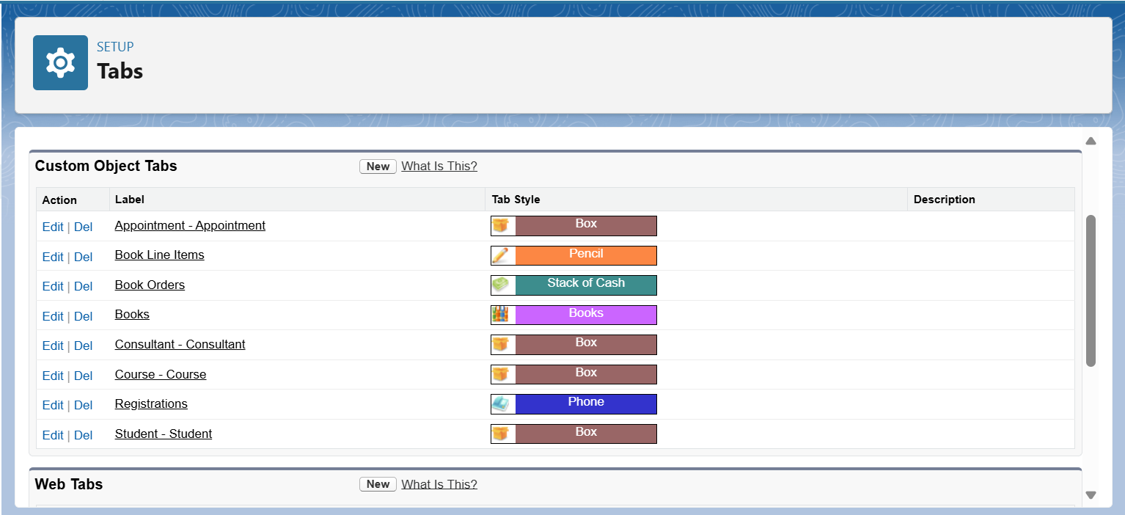

**ScreenFlow for Student Admission Application Process:**

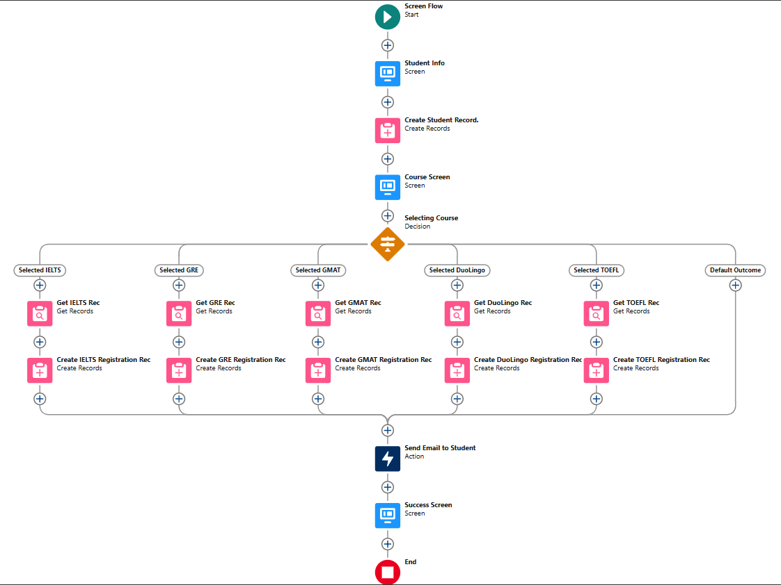

**Create User:**

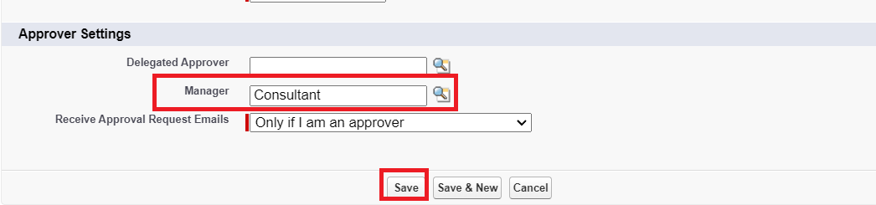

**Create an Approval Process For Property Object:**

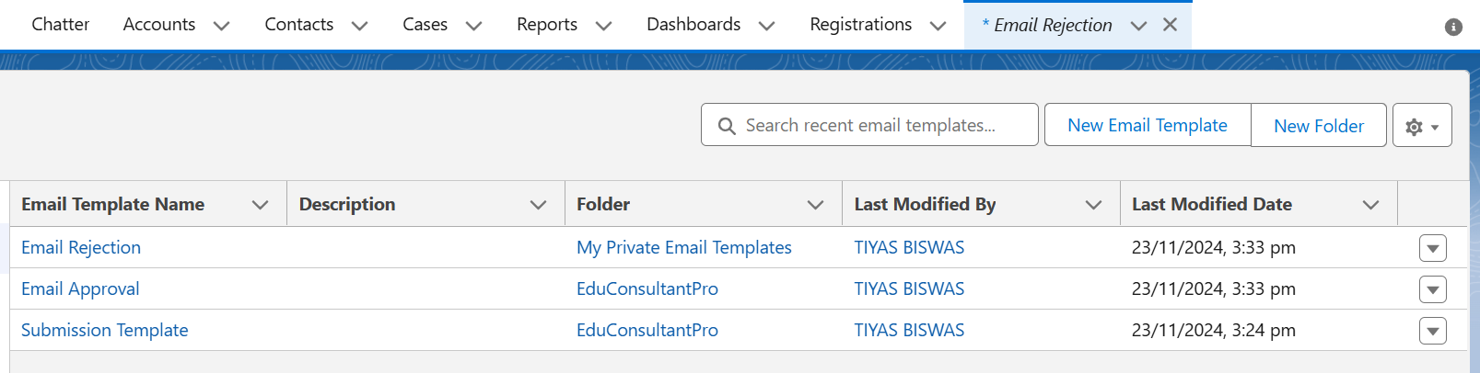

**Create a Record Triggered Flow:**

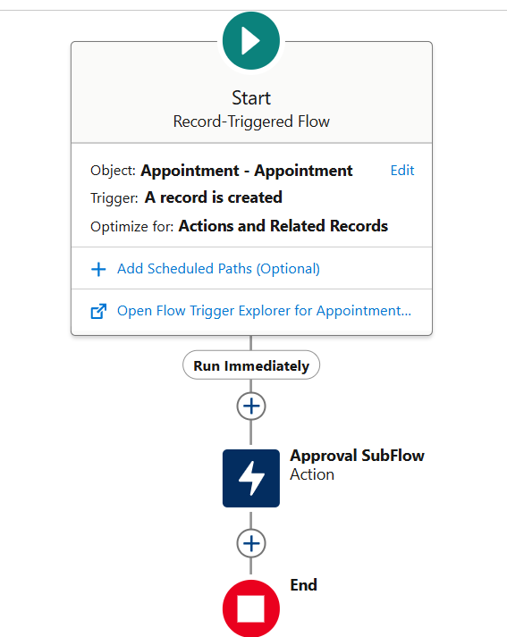

**Create a ScreenFlow For Existing Students to Book an Appointment:**

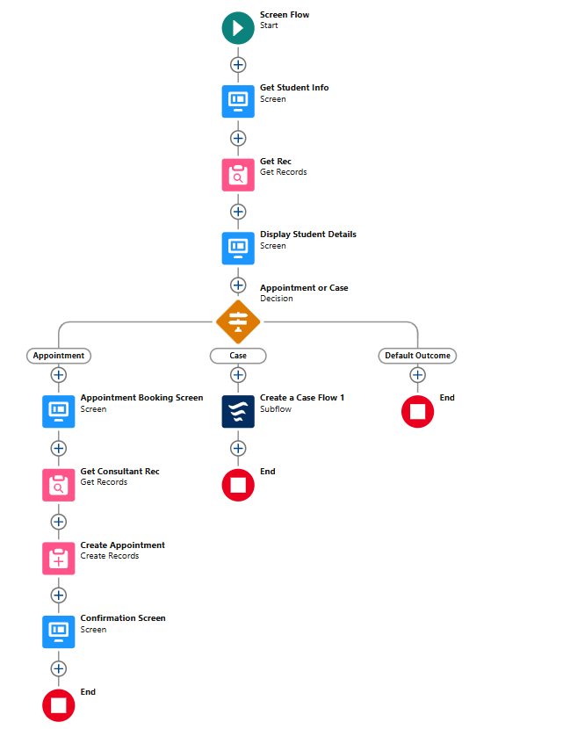

**Create a ScreenFlow to Combine All the Flows at One Place:**

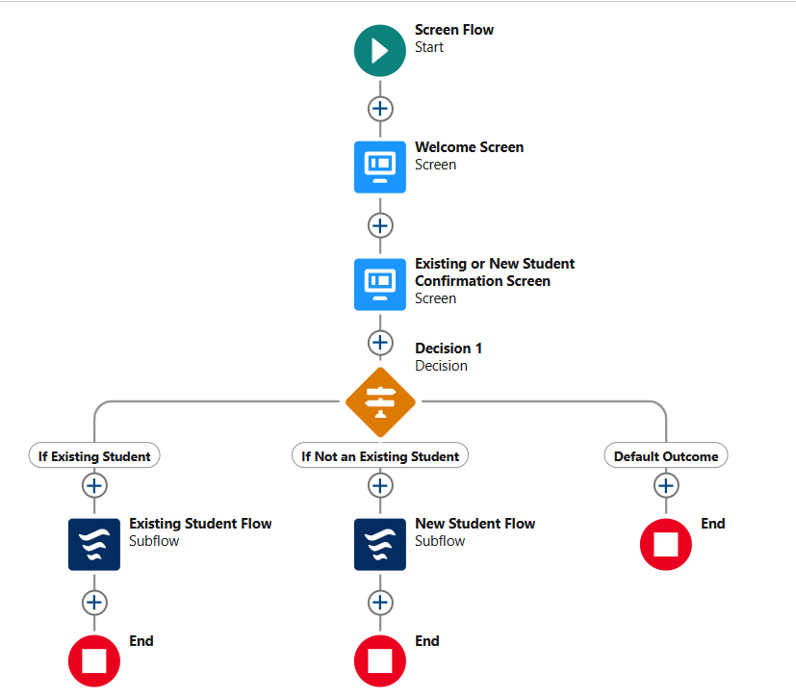

**A Lightning App Page:**

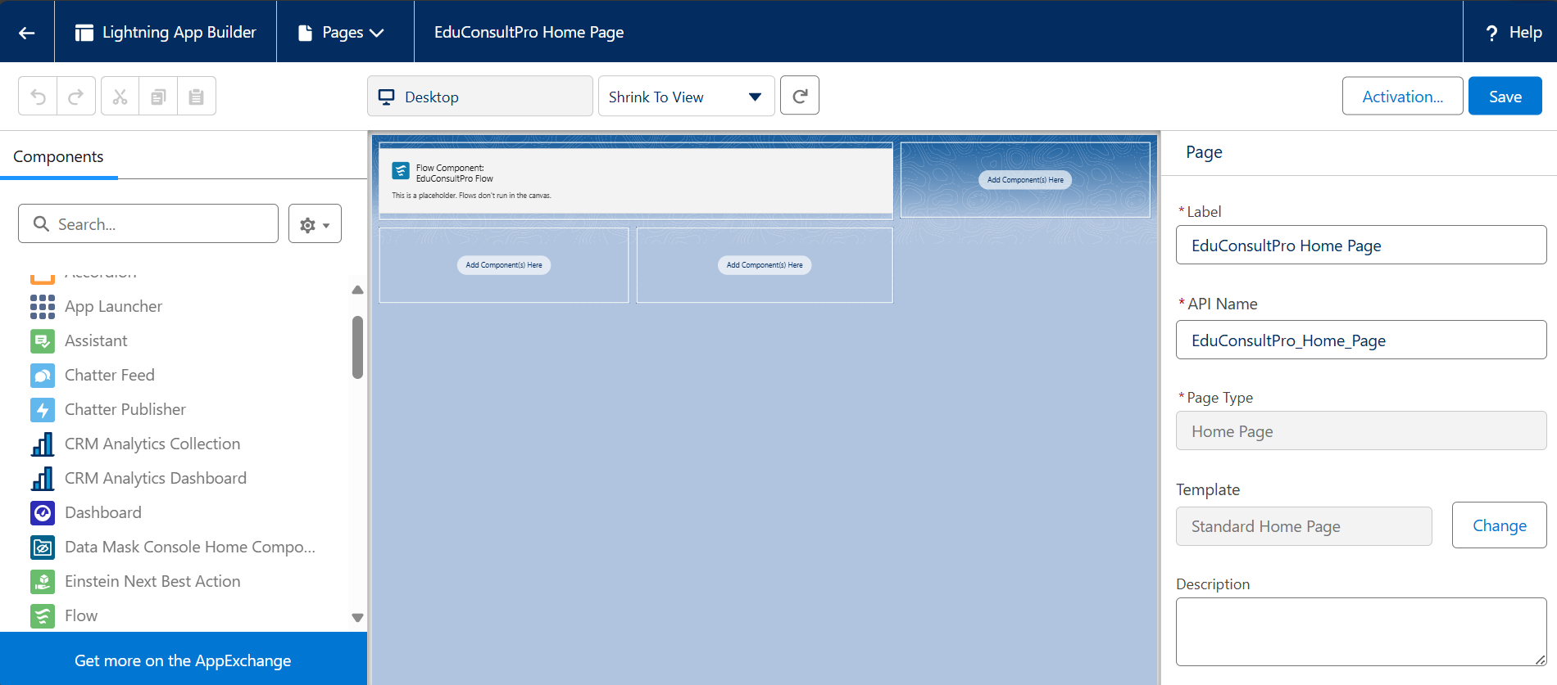

**5. Testing and Validation**

The project includes rigorous testing and validation to ensure quality:

- User Interface Testing: Ensuring usability and functionality for staff and students.

**6. Key Scenarios Addressed by Salesforce in the Implementation Project**

Salesforce addresses several scenarios during implementation:

- Managing a high volume of student enquiries and applications.

- Providing timely updates and feedback to prospective students.

- Streamlining consulting services through effective case management.

**7. Conclusion**

The implementation of Salesforce CRM for EduConsultPro Institute has successfully streamlined the admission and enquiry processes, enhanced the transparency of operations, and provided a seamless experience for both students and staff. This project demonstrates the power of Salesforce CRM in transforming educational services to meet modern demands.